

7

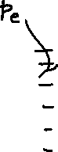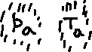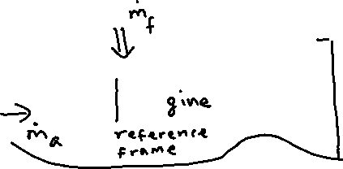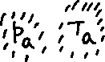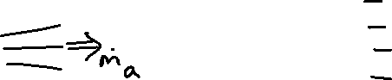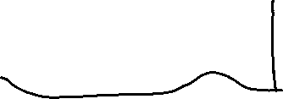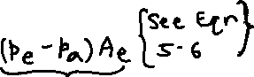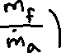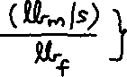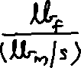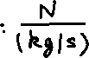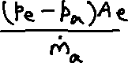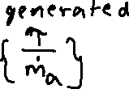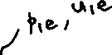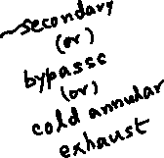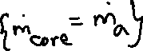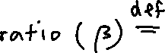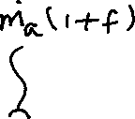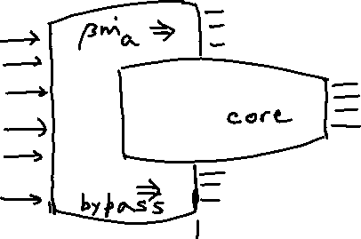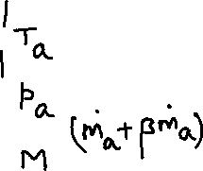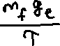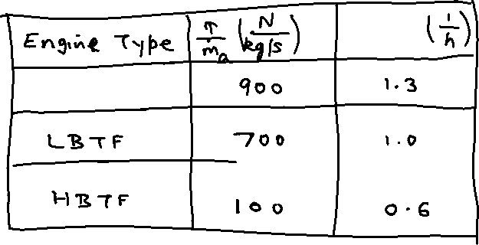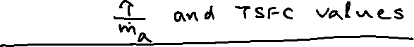

Turbofan engine example:

A HBTF engine has the following characteristics:

Flight velocity (u) 250 m/s

Core mass flow rate (${\dot{m}}_{a}$) 100 kg/s

Bypass ratio () 6

Core exit velocity (ue) 550 m/s

Bypass exit velocity (u1e) 370 m/s

Core jet exit pressure (pe) is equal to ambient pressure (pa)

Bypass jet exit pressure (p1e) is equal to ambient pressure (pa)

Fuel-air ratio ($f$) 0.02

Questions:

1. What is the engine mass flow rate?
2. Calculate the fuel mass flow rate.
3. What is the thrust generated by the core?
4. What is the thrust generated by the bypass?
5. What is the total thrust?
6. What percentage of the thrust is generated by the bypass stream?
7. What is the engine specific thrust?
8. Determine the TSFC of the engine.

Answer:

1. The engine mass flow rate = $\left({\dot{m}}_{core}+{\dot{m}}_{bypass}\right)=\left({\dot{m}}_{a}+β{\dot{m}}_{a}\right)={\dot{m}}_{a}\left(1+β\right)$

$$=100\left(1+6\right)=700 kg/s$$

${\dot{m}}_{f}=f{\dot{m}}_{a}=\left(0.02\right)\left(100\right)=2\frac{kg}{s}=7200 kg/h$

$τ_{core}={\dot{m}}_{a}\left(1+f\right)u_{e}-{\dot{m}}_{a}u+\left(p_{e}-p_{a}\right)A_{e}=100\left(1+0.02\right)\left(550\right)-100\left(250\right)+0$

$=31100 N$

$τ_{bypass}={β\dot{m}}_{a}u_{1e}-{β\dot{m}}_{a}u+\left(p_{1e}-p_{a}\right)A_{1e}=\left(6\right)\left(100\right)\left(370\right)-\left(6\right)\left(100\right)\left(250\right)+0$

$=72000 N$

$τ=τ_{core}+τ_{bypass}=31100+72000=103100 N$

1. % of thrust generated by the bypass stream = (72000/103100)(100) = 69.8%
2. Engine specific thrust = 103100/700 = 147.3 N/(kg/s)
3. TSFC = $\left({{\dot{m}}_{f}}/τ\right)=\left(2/{103100}\right)=1.9399\left({10}^{-5}\right)\frac{kg}{s}=19.399 \left(\frac{{mg}/s}{N}\right)$

(TSFC)wb = (TSFC) ge = 1.9399 (10-5) (9.81) = 1.9030 (10-4) s-1 = 0.685 h-1

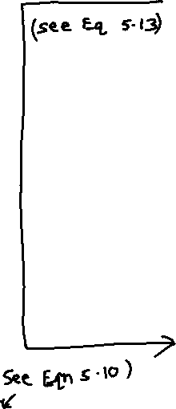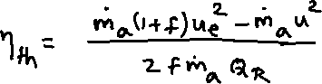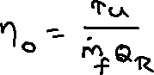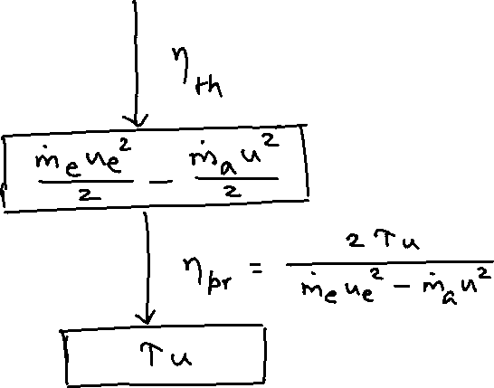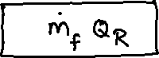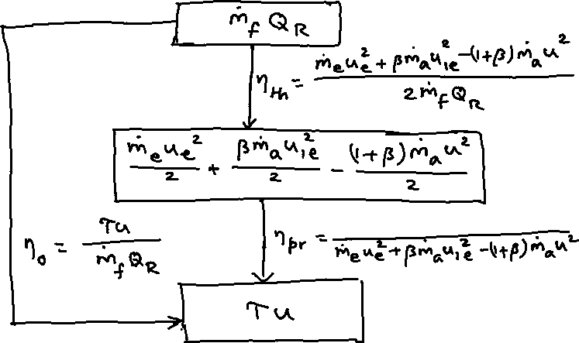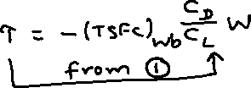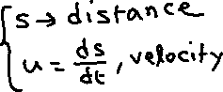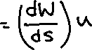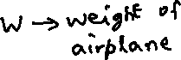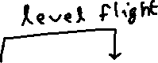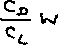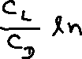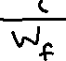

Example:

A transport aircraft has wing area S = 93 m2 and drag polar CD = 0.015+0.05CL2. Its engines have TSFC of 0.6 h-1. Calculate the range of the aircraft for flight at u = 250 m/s and altitude 11000 m (density = 0.37 kg/m3, temperature = 217 K). The aircraft mass at the beginning of cruise is 45000 kg and the cruise fuel available has mass 9100 kg.

q∞ = ½ r∞u2 = ½ (0.37) (2502) = 11563 N/m2

CL = L/( q∞S) = W/( q∞S) = [(45000)(9.81)]/[(11563)(93)] = 0.41

CD = 0.015+0.05(0.412) = 0.023

Mini = 45000 kg, Mfin = (45000-9100) = 35900 kg

(Wini/Wfin) = (Mini/Mfin)

(TSFC)wb = 0.6 h-1 = 0.6 (3600-1) = 1.6667 (10-4) s-1

= 6.040 (106) m = 6040 km = 3776 mi = 3283 nm

{The speed of sound (a∞) = (gRT∞)1/2 = [(1.4)(287)(217)]1/2 = 295.3 m/s at cruise altitude.

Flight Mach number M = (u/a∞) = 0.85}